Exercise 1 (Setting Up JUnit)

package org.example;  
  
public class Calculator {  
  
 public int add(int a, int b) {  
 return a + b;  
 }  
  
}

TEST

package org.example;  
  
import static org.junit.jupiter.api.Assertions.\*;  
import org.junit.jupiter.api.Test;  
  
class CalculatorTest {  
  
 @Test  
 public void testtwoplustwoequalsfour() {  
 Calculator calc = new Calculator();  
 *assertEquals*(4, calc.add(2, 2));  
 }  
 @Test  
 public void testfiveplusfiveequalsten(){  
 Calculator calc = new Calculator();  
 *assertEquals*(10,calc.add(5,5));  
 }   
}

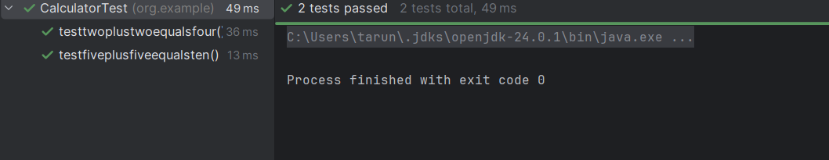OUTPUT

Exercise 2(Writing Basic JUnit Tests)

package org.example;  
  
public class Vote {  
 public String voter(int age){  
 if(age>=18){  
 return "you are eligible for voting";  
 }  
 else {  
 return "you are not eligible for voting";  
 }  
 }  
}

TEST

package org.example;  
  
import org.junit.jupiter.api.Test;  
  
import static org.junit.jupiter.api.Assertions.\*;  
  
class VoteTest {  
 @Test  
 public void testeligiblevoter(){  
 Vote vote=new Vote();  
 *assertEquals*("you are eligible for voting",vote.voter(19));  
 }  
 @Test  
 public void testnoteligiblevoter(){  
 Vote vote=new Vote();  
 *assertEquals*("you are not eligible for voting",vote.voter(9));  
 }  
}

OUTPUT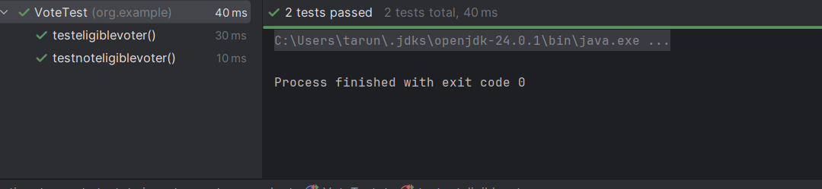

EXERCISE 3(Assertions in JUnit)

package org.example;  
  
public class Assertion {  
 public int add(int num1,int num2){  
 return num1+num2;  
 }  
 public boolean greater(int num1,int num2){  
 return num1>num2;  
 }  
  
}

TEST

package org.example;  
  
import org.junit.Test;  
import static org.junit.Assert.\*;  
  
public class AssertionsTest {  
  
 @Test  
 public void testAssertions() {  
 Assertion obj = new Assertion();  
 *assertEquals*(5, obj.add(2, 3));  
 *assertTrue*(obj.greater(5, 3));  
 *assertFalse*(obj.greater(3, 5));  
 Object obj1 = null;  
 *assertNull*(obj1);  
 Object obj2 = new Object();  
 *assertNotNull*(obj2);  
 }  
}

OUTPUT

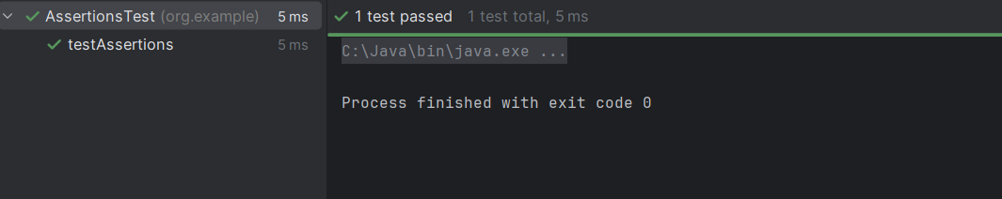

EXERCISE 4 (Arrange-Act-Assert (AAA) Pattern, Test Fixtures, Setup and Teardown Methods in JUnit)

package org.example;  
  
public class Calculator {  
  
 public int add(int a, int b) {  
 return a + b;  
 }  
  
}

TEST

package org.example;  
  
import static org.junit.jupiter.api.Assertions.\*;  
import org.junit.jupiter.api.Test;  
  
class CalculatorTest2 {  
 Calculator calc =new Calculator();  
 @Test  
 void testAddFivePlusFive() {  
 int output = calc.add(5, 5);  
 *assertEquals*(10, output);  
 }  
 @Test  
 void testAddTenPlusTen() {  
 int output2 = calc.add(10, 10);  
 *assertEquals*(20, output2);  
 }  
}

